The Aristotelian Society
www.aristoteliansociety.org.uk

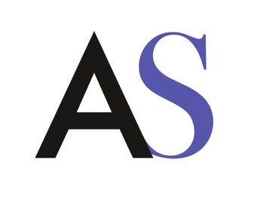

Student Bursary Application Form 2022/23

- Personal Details

Surname:
Other names:
Title:
Address:
Postcode:
Email address:

- Ongoing Education
Will you be registered full time in the UK for a higher degree in philosophy in 2022/23?

State the course you will be registered for in 2022/23, the year of the course, and when you expect to complete your course or submit your PhD (e.g. Third year student at UCL, submitting in September 2022).

- Past Education
Dates attended | University | Subject | Type of degree | Class awarded

- Other sources of funding
Please give details of any award you expect to receive in 2022/23, including fees only awards. If your circumstances change, you must inform the Managing Editor immediately.

- Research Proposal
Please describe your research plans in 2022/23 (max. 500 words).

- Referees
Please give the names and contact details of two referees who will write directly to the Managing Editor at postgrad@aristoteliansociety.org.uk in support of your application.
Please note that it is your responsibility to ensure that your referees send in their references by the deadline.
Referee 1
Name and title:
University:
Email address:

Referee 2
Name and title:
University:
Email address:

- Are you a member of the Aristotelian Society? Yes
Please note that applicants must be a member of the Society. You can join at http://www.aristoteliansociety.org.uk/membership/join-the-society/

I confirm that to the best of my knowledge the above information is correct.

Signature ............................................................................................. Date …………

Please submit your application along with a CV to the Managing Editor of the Aristotelian Society, Holly de las Casas, at postgrad@aristoteliansociety.org.uk with the subject line “2022/23 Student bursary application”.

Applications must be received no later than Friday 11 June 2022.

