Aristotelian Society
www.aristoteliansociety.org.uk

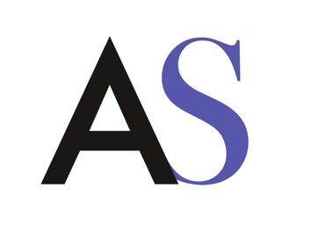

Administrator / Web Editor Job Application Form
Surname ............................
Other names: ............................
Address ............................
Telephone ............................

Please include any skills and experience you have acquired that can support this application under each of the following sections:

Education and training (please include details of time to completion for any current course you are on, e.g. if you are undertaking a PhD, how many months until your submission date)
............................

Administrative Experience
............................

Web editing experience
............................

Organising & Running Events
............................

Social Media and Publicity
............................

Why do you want to work for the Aristotelian Society?
............................

Do you consider yourself to have a disability?

Yes No Rather not say

Please tell us if there are any reasonable adjustments we can make to assist you in your application or with our recruitment process
............................
Please tell us if there are any dates when you will not be available for interview
............................
I can confirm that to the best of my knowledge the above information is correct. I accept that providing deliberately false information could result in my dismissal.

Signature .................................................. Date …………

Please submit your application form along with a CV to anna.stelle@aristoteliansociety.org.uk with the subject line: “Administrator / Web Editor Job Application”.

Applications must be received no later than Friday 8th September 2023.

